Hoofdstuk 10: samenvatting
Lees eerst het boek en gebruik dan deze samenvatting.
Bladzijdenummering niet 100% accuraat!

5) Muscles and animal movement
- Tenton (connective tissue anchoring muscle), muscle fibers (long multinuclear cylindrical cells; myoblast → myotube → muscle cell) consisting of myofibrils (parallel subunits), build op from sacromeres (functional unit).
- Sacromere consists myofillaments: 2 proteins: actin and myosin. Z-disk binds actin (with α-actin). A band (actin), M line, H zone (around M line), I band (around Z disk, between A bands).
- Myosin thicker actin. Cross-bridges (actin projections that transiently bind myosin during contraction).
- Two G-actin molecules (globular) polymerize to form F-actin (filamentous) helix, tropomysin in groove. Also troponin complexes attached filament. Myosin 3 pairs proteins: myosin heavy chains (long, thin, twisted, globular head), essential and regulatory light chains (bind calcium).
- Myosin aggregates (bare piece middle two directions molecules).
- Sliding filament theory.
- Increase in tension during contraction (more contact filaments).
- Myosin acts as ATPase, release ADP fast if actin binds myosin.
- Chemomechanical transduction, three motor molecules: myosin, kinesin, dynein (each ATPase and interaction filamentous protein).
- All “walk” along other molecules.
- Myosin binds actin when ADP-P_{i} is bound, force created when P_{i} is released and “neck” rotates (because strength bond increases), then ADP release, ATP binding, release of head, ATP→ADP+P_{i}→return “cocked” position.
- Isometric contraction (same length) vs isotonic contraction (same tension). V = (b(P_{o}-P))/(P+a) (V = velocity, P force/load, P_{o} max tension; “what is left goes to speed”).
- power = F∙ΔL/t (power max 0.4 V/V_{max}).
- Cross-bridges can attach only in force-generating position.
- Fixed time required cross-bridge to detach. At V_{max} not net force cross-bridges.
- Troponin binds tropomysin with troponin T, troponing C binds Ca²⁺ changing its conformation, allowing cross-bridges by tropomysin interaction (troponin, T, C, I, which binds actin and C). Ca²⁺ thus needed tension.
- Excitation-concentration-coupling: AP → release calcium internal storage.
- Transverse tubule (T-tubule; runs around Z-disk) continuous plasma membrane (→ AP inside fiber). Sarcoplasmic reticulum (SR) sequesters calcium (→ cellular [Ca²⁺]↓).
- Ca²⁺ bound calsequestrin SR → ↓[Ca²⁺].
- Ryanodine receptors span SR membrane, half lined up dihydropyridine receptors on T-tubule (voltage-gated Ca²⁺ channels). ΔV dihydropyridine conformational change → associated ryanodine receptors open → calcium efflux SR → other dihydropyridine receptors open (calcium induced calcium release). Ca²⁺ quickly binds troponin, to be released when [Ca²⁺]↓.
- contraction-relaxation cycle:
Contraction-relaxation cycle.
- AP → Depolarization membrane.
- Conducted by T tubules.
- → Dihydropyridine conformational change → opening Ca²⁺ channels.
- Active level Ca²⁺, V_{m} → V_{rest} → closure channels.
- Binds troponin →→ cross-bridges.
- Cross bridges produce force.
- “Rowing” of cross bridges.
- Transporting back of Ca²⁺
- Latent period (~2ms). Repeated individual contractions fibers → useful muscle contractions.
- Parallel elastic component muscles (plasma membrane, parallel connective tissues) and series elastic components (tendons, connective tissues, Z disks).
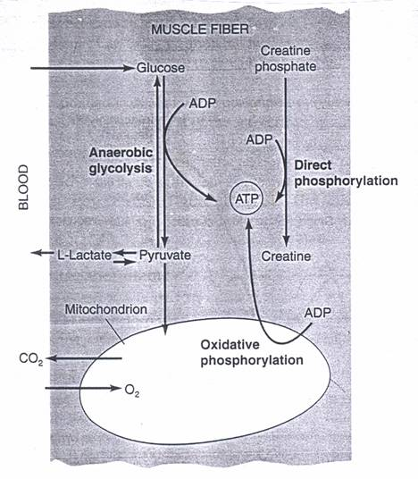
- Plastic series slack → 10-500 ms till tension. Active state (increased stretch resistance by formation cross bridges & slight internal shortening) Twitch (brief increase tension by cross bridge activity), tetanus (prolonged active state after barrage high frequency APs). External isometric tension not immediate max, only after tetanus.
- Summation of contraction (release Ca²⁺ & series elastic component not returning slack).
- ADP → ATP by creatine phosphokinase from creatine phosphate. Normal conditions ATP replenished oxidative (mitochondria) or anaerobic metabolism (glucose → pyruvate → lactate). During high intensity creatine phosphokinase short time, until ox/an catches up.
- Varying properties various fiber types (electrical properties, cross-bridge detachment, #calcium pumps, #mitochondria): 1 tonic fiber (contract slowly, no twitch; no APs, neuron runs along fiber; slow myosin detachment → low V_{shortening} & isometric tension easily), 3 twitch fibers.
- 3 twitch fibers: slow twitch (type I; contract slowly & fatigue slowly; #↑mitochondria, rich blood supply, ATP usage↓), fast-twitch oxidative (type IIa; rapid repetitive motion; ↑mitochondria), fast-twitch glycolytic (type IIb; contract rapidly, fatigue quickly; few mitochondria, anaerobic glycolyse).
- Speed vs energetic cost. ATP hydrolysis exothermic → heat. Energetic properties depend V and V/V_{max} (high V_{max} → stronger/more ATP usage).
- – 421. (..)

